Title: Day 2 – Design for IoT Smart Home Dashboard
Date: 7 Sept 2025

Introduction:
On Day-1, I gathered requirements for the IoT Smart Home Dashboard.
On Day-2, the focus is on the design phase. I created diagrams to represent how the system will be structured, how devices connect to the application, and how data flows to databases.

The following diagrams are included:
- System Architecture Diagram
- Use Case Diagram
- Class Diagram

System Architectural Diagram:
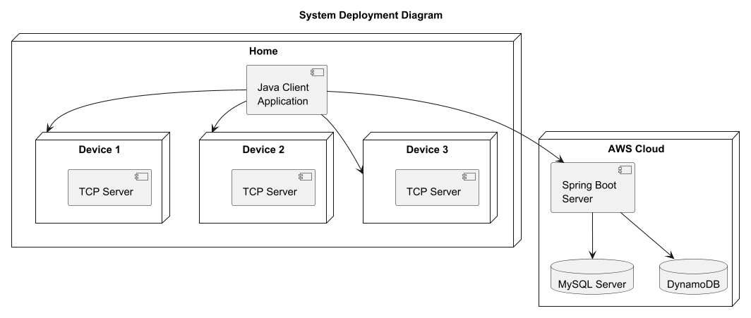
Diagram Explanation:
- The Customer interacts with the system using a Java console-based client application (TUI).
- The application connects to:
- MySQL Server → for storing customer details and gadget metadata.
- DynamoDB → for storing time-series data of device status changes (future scope).
- Device Discovery API → scans the local network and lists available devices.
- The Device Discovery API will:
  - Scan for devices connected in the local network and list all devices not yet registered.
  - Confirm the device by prompting the user (for example, hearing a beep sound to validate it).
  - Assign a location such as Bedroom, Hallway, Kitchen to complete the registration.

Device & Gateway Deployment
Devices (TV, AC, Fan, Light, Robo Vac & Mop) are represented as TCP Servers, simulating IoT devices.
The Java Client Application (TUI) acts as the controller and gateway.
The client communicates with devices using device-specific protocols — protocol packets are sent over TCP connections to control each device.
The application also sends metadata to MySQL and logs telemetry into DynamoDB (AWS cloud).
For the cloud/server layer, I have shown Spring Boot Server in the diagram.
Note: Currently I may use plain Java, but Spring Boot is shown for design extensibility. In the future, I may switch frameworks depending on requirements.

Use Case Diagram:
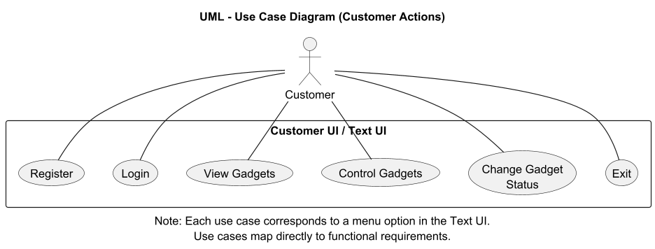
Diagram Explanation:
- Actor: Customer.
- Use Cases: Register, Login, View Gadgets, Control Gadgets, Change Gadget Status, Exit.
- Each use case corresponds to one menu option in the TUI.

Class Diagram:
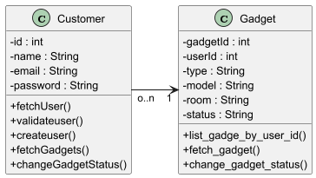
Diagram Explanation:
- Customer class manages user registration, login, and gadget fetch operations.
- Gadget class represents IoT devices and their metadata (id, type, model, room, status).
- Methods like createUser(), validateUser(), fetchGadgets(), and changeGadgetStatus() map directly to system functionality.
- Multiplicity: one customer can own many gadgets (0..n to 1 relation).

DEVICE DISCOVERY:
- Device Discovery is an essential feature to register new devices:
- Devices connected in the same local network are scanned.
- The system validates the correct device by triggering a beep or signal.
- Once confirmed, the device is assigned to a specific room (Bedroom, Hallway, Kitchen, etc.).
Conclusion:
On Day-2, I completed the design phase by preparing architecture, class, use case, and deployment diagrams for the IoT Smart Home Dashboard.
These diagrams clearly show how the system components (customer, application, devices, databases) will interact.
This design will guide the coding phase starting from Day-3, where implementation of Java APIs begins.

